LABORATORY 7 REPORT

Vacuum technology

Laboratory leader: Ph.D. Błażej Witkowski
Date: 29.01.2026
Group: Kinga Berenc 257117
Julia Pietrzak 257125
Zofia Walas 257131
Anna Zielińska 257132
Jakub Ejtaszewski 257122
Stanisław Kotowicz 257100
Adam Jóźwiak 257097
Grade: ……………………………………

Aim of the laboratory
The aim of this laboratory is to get acquainted with vacuum technology by studying the various methods and terminology used to generate negative pressure. It involves analysing the physical principles of ejectors, Venturi tubes and mechanical vacuum pumps. Additionally, the objective is to understand the practical selection of suction cup shapes.

Introduction
Pneumatic and vacuum systems are widely used in industrial automation because they are simple, reliable, and relatively inexpensive. Pneumatic drives convert the energy of compressed air into mechanical motion, most often using linear actuators controlled by directional valves. The speed and smoothness of motion can be adjusted by flow-control components such as throttle check valves, which restrict airflow in one direction while allowing free flow in the opposite direction.
Vacuum technology is commonly combined with pneumatics for handling and transporting workpieces using suction cups. Vacuum is defined as a pressure lower than atmospheric pressure and it can be generated in different ways depending on the application. In this laboratory, two methods of vacuum generation were considered: mechanical vacuum pumps, which remove air from a closed volume using an electric drive, and pneumatic ejectors that produce vacuum using the Venturi effect. In ejector systems, compressed air passes through a nozzle, the flow velocity increases, and the static pressure drops creating suction at a side port.
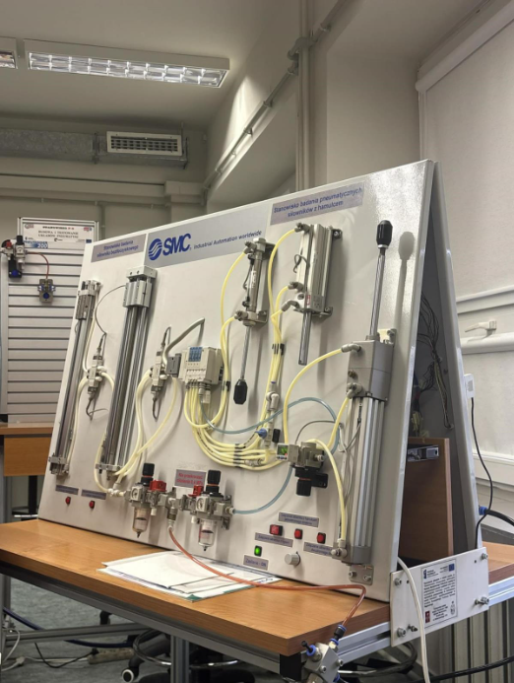
Figure 1 Model used during laboratory

- Transport without a piston rod (rodless cylinder)
A linear actuator where the piston moves inside a long tube, and the load is moved by an external carriage without a sticking-out rod - rodless design, often magnetically coupled or mechanically slotted.
- Great for transporting parts over longer strokes in a compact space
- No rod means no bending risk and less installation length
Typical uses: pick-and-place transfer, sliding tables, shuttles.

- Transport with a piston rod (standard cylinder)
The classic pneumatic cylinder: air pressure pushes a piston, and the force is delivered through a piston rod that extends.
- Simple, cheap, reliable
- Easy to mount and control (often double-acting)
Limitations:
- Needs extra space for the rod extension
- Long rods can flex under side loads
Typical uses:
pressing, pushing, clamping, lifting.

- Pressure sensing
A sensor (vacuum switch or pressure switch) that monitors vacuum level and gives an electrical signal.
Why it’s used:
- To detect loss of vacuum (part dropped, leak, clogged filter)
- To confirm part is gripped before moving
- Holding brake
An actuator that includes a mechanical locking device – brake. It can stop and hold position even if air pressure is lost.
- Safety: holds a vertical load so it doesn’t fall
- Can stop mid-stroke and hold position
Why it “produces a lot of heat”:
If the brake is used to stop motion frequently or while sliding, friction converts motion energy into heat

Summary
Negative pressure – gaseous state where the pressure is lower than atmospheric pressure.

Different ways to create a vacuum
Machining vacuum pump
The operating principle is the opposite of compressors. These devices are powered by electric motors, the suction port is connected to the volume where a reduction in pressure is required. During operation, the air extracted from this space is discharged into the atmosphere.
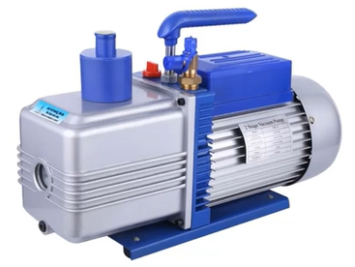
Figure 2 Vacuum pump
Ejectors
These devices function based on the principles of a Venturi tube. A stream of compressed air is directed through a nozzle. The reduction in cross-sectional area causes an increase in the velocity of the air stream.
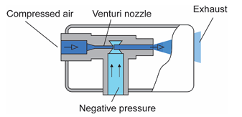
Figure 3 Ejector
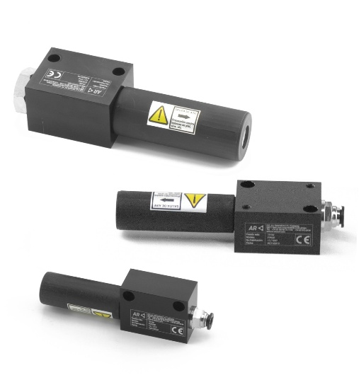
Figure 4 Ejectors
Task 1: Describe three programs of manipulator. Based on manipulator schema, describe positioning method for pneumatic actuators.

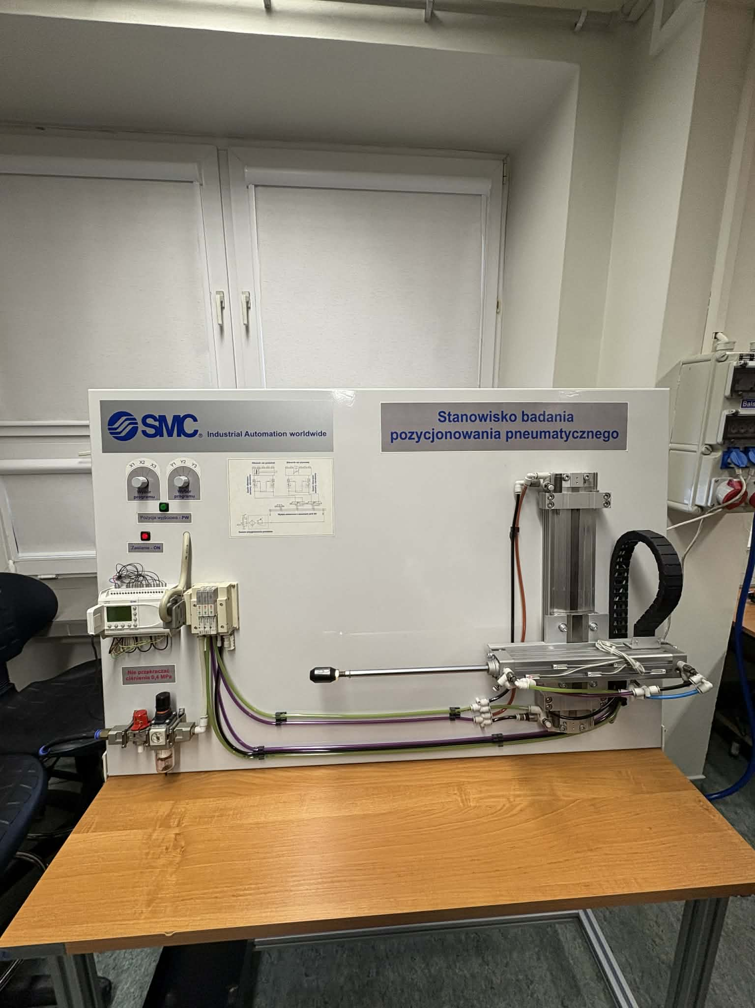
Figure 5 pneumatic positioning workstation.

System Configuration
The manipulator is built as a dual-axis pneumatic system consisting of two independent actuators: one responsible for horizontal motion and the other for vertical motion. Each actuator is supplied with compressed air and controlled by dedicated pneumatic valves that regulate the direction and flow rate of the air. These valves play a key role in controlling the speed and direction of movement along each axis.
In addition, both actuators are equipped with position sensors that continuously monitor the current location of the pistons. The signals from these sensors are transmitted to the control system, allowing real-time feedback and precise supervision of the manipulator’s motion.

Adjustment and Testing
To achieve smooth and accurate operation, the airflow was carefully adjusted using fine valve regulation. This calibration process allowed optimisation of both the speed and stability of the system. After tuning, the manipulator was tested using three predefined motion programs. Each program commanded the manipulator to move to selected coordinates within a fixed grid, verifying repeatability and positioning accuracy.

Program Descriptions
Three control programs were implemented and tested during the experiment:
- Program X1, Y1 moves the manipulator sequentially through the diagonal positions (1,1), (2,2), (3,3), (4,4), and (5,5). This program demonstrates continuous coordinated motion along both axes.
- Program X2, Y2 focuses only on two specific points: (2,2) and (4,4). This program tests the system’s ability to move directly between distant positions without intermediate stops.
- Program X3, Y3 guides the manipulator through positions (1,1), (2,2), (3,3), and (5,5), intentionally skipping position (4,4). This verifies the flexibility of the control logic and selective positioning.

Positioning Mechanism of Pneumatic Actuators
Movement in both actuators is achieved by directing compressed air into one side of the piston chamber. This creates a pressure difference that forces the piston to move in the desired direction. As the manipulator approaches a target coordinate, the position sensors detect the exact piston location and send a signal to the control system.
Once the target position is reached, compressed air is simultaneously introduced into the opposite side of the piston. This counteracting pressure balances the forces and effectively stops the piston, preventing further movement. As a result, the manipulator remains stabilised at the selected point.
This closed-loop control method ensures precise and repeatable positioning, which is essential for applications requiring high accuracy and reliable motion control.

Scheme:
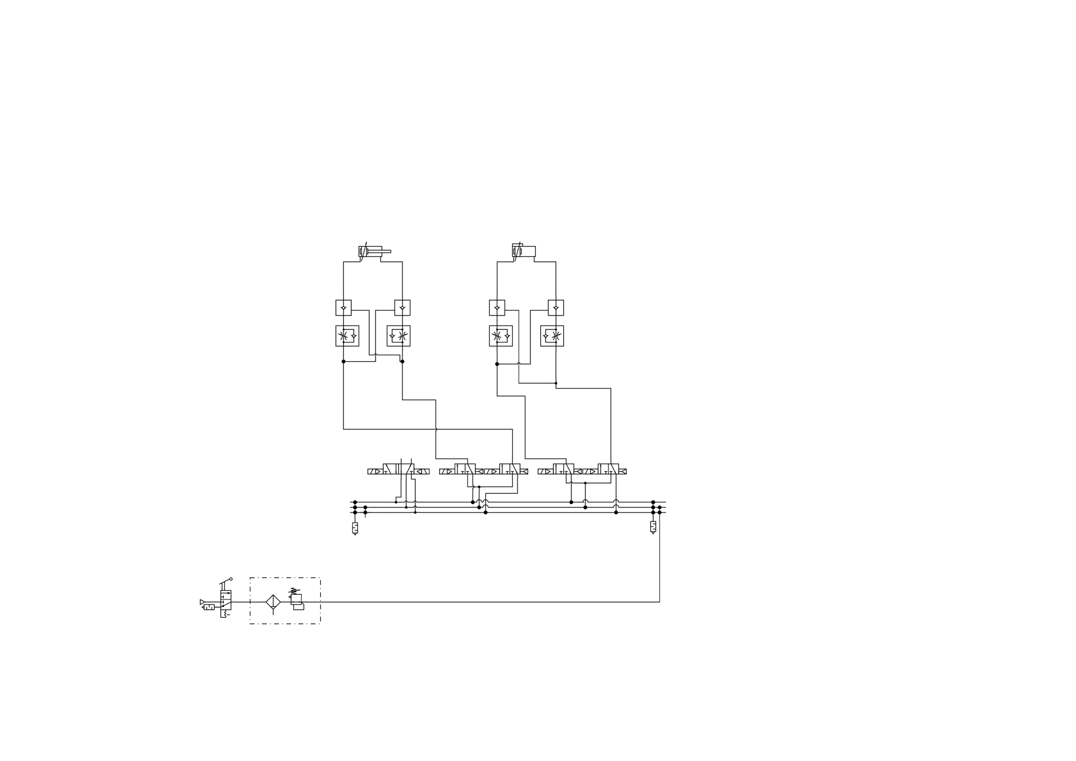

Task 2: Describe the different types of suction cups - construction, purpose, material, which item to use for.
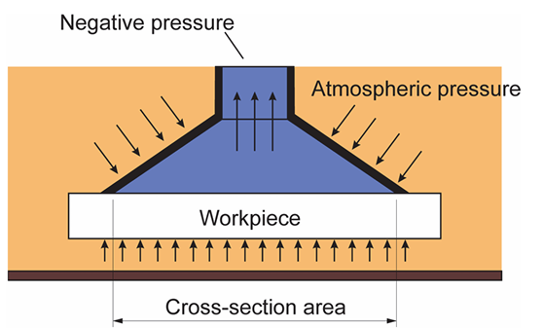
Figure 6 Simplify operation of the suction cup
Microsoft Word - Manufacturing - Instructions for Laboratory v8 after revision. AGdocx.docx
Table 1 Materials use to suction cup.
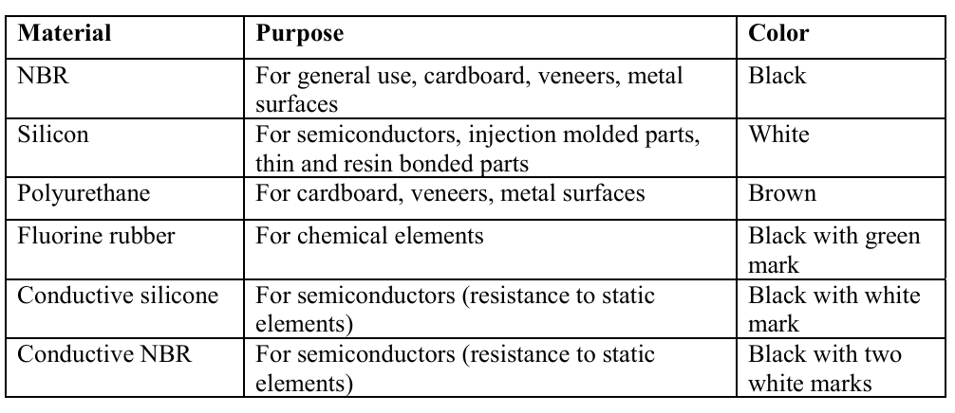
Microsoft Word - Manufacturing - Instructions for Laboratory v8 after revision. AGdocx.docx

Table 2 Shape of suction cup.
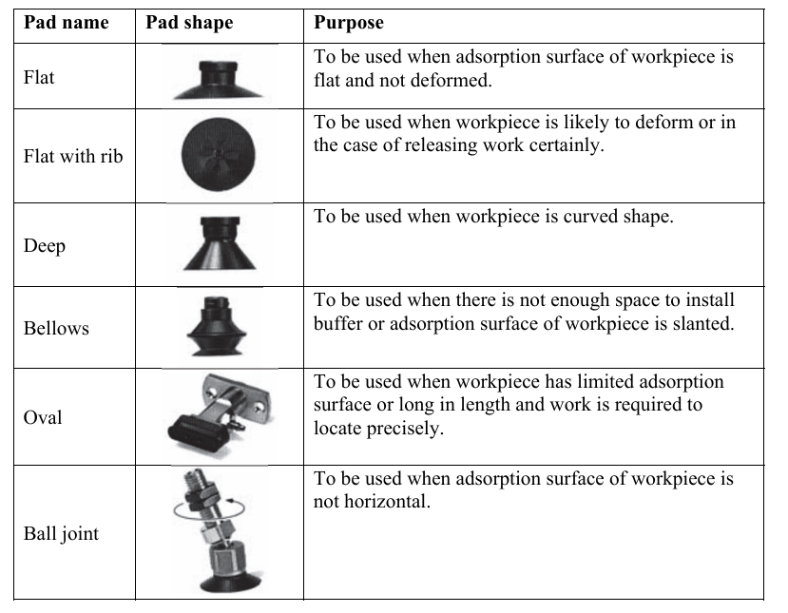
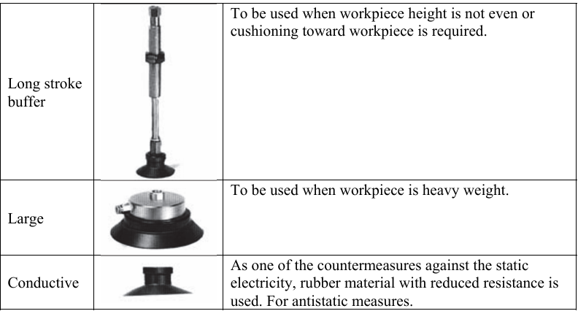
Microsoft Word - Manufacturing - Instructions for Laboratory v8 after revision. AGdocx.docx

Cross-section of suction cups:

Description:
Suction cups (also called vacuum pads) are used to grab and move parts using vacuum power. They work on a simple principle – the pressure under the cup drops below atmospheric pressure, so the outside air essentially pushes the pad against the workpiece and holds it in place. How strong that grip is depends mainly on how big the pad's surface area is and how much vacuum you're pulling.
Construction and Mounting
You can mount vacuum pads in two main ways: rigidly fixed or in a holder with a shock-absorbing buffer. The buffered version is really handy when you're dealing with uneven surfaces or parts at different heights, because it can compensate for those irregularities and maintain solid contact when picking things up.
Materials (Choosing Based on What You're Handling and Where)
The material you pick depends on what you're grabbing and the environment you're working in:
- For everyday industrial handling, NBR (black) works well for cardboard, veneers, and metal surfaces. Polyurethane (brown) handles similar jobs too.
- For delicate stuff like electronics, go with silicone (white) – it's perfect for semiconductors, injection molded parts, and thin or resin-bonded components.
- If you need chemical resistance, fluorine rubber (black with a green mark) is your friend.
- For antistatic or ESD-sensitive applications (think semiconductors), you'll want conductive silicone (black with white mark) or conductive NBR (black with two white marks) because they have lower electrical resistance.
Shapes (Matching the Pad to the Job)
The shape you choose depends on the part's geometry and how you're handling it:
- Flat pad – for flat surfaces that won't bend or deform
- Flat with rib – when parts might deform or you need reliable release
- Deep pads – for curved workpieces
- Bellows pads – great when the surface is angled or you don't have room for a separate buffer
- Oval pads – perfect for long or narrow parts where you don't have much surface area to work with and need precise positioning
- Ball joint type – helps when the surface isn't horizontal
- Long-stroke buffer – tackles tricky height variations
- Large pads – for heavy workpieces
- Conductive versions – whenever you need antistatic protection

Task 3: Perform the functional characteristics of the ejector in function of the generated vacuum on the supply pressure.

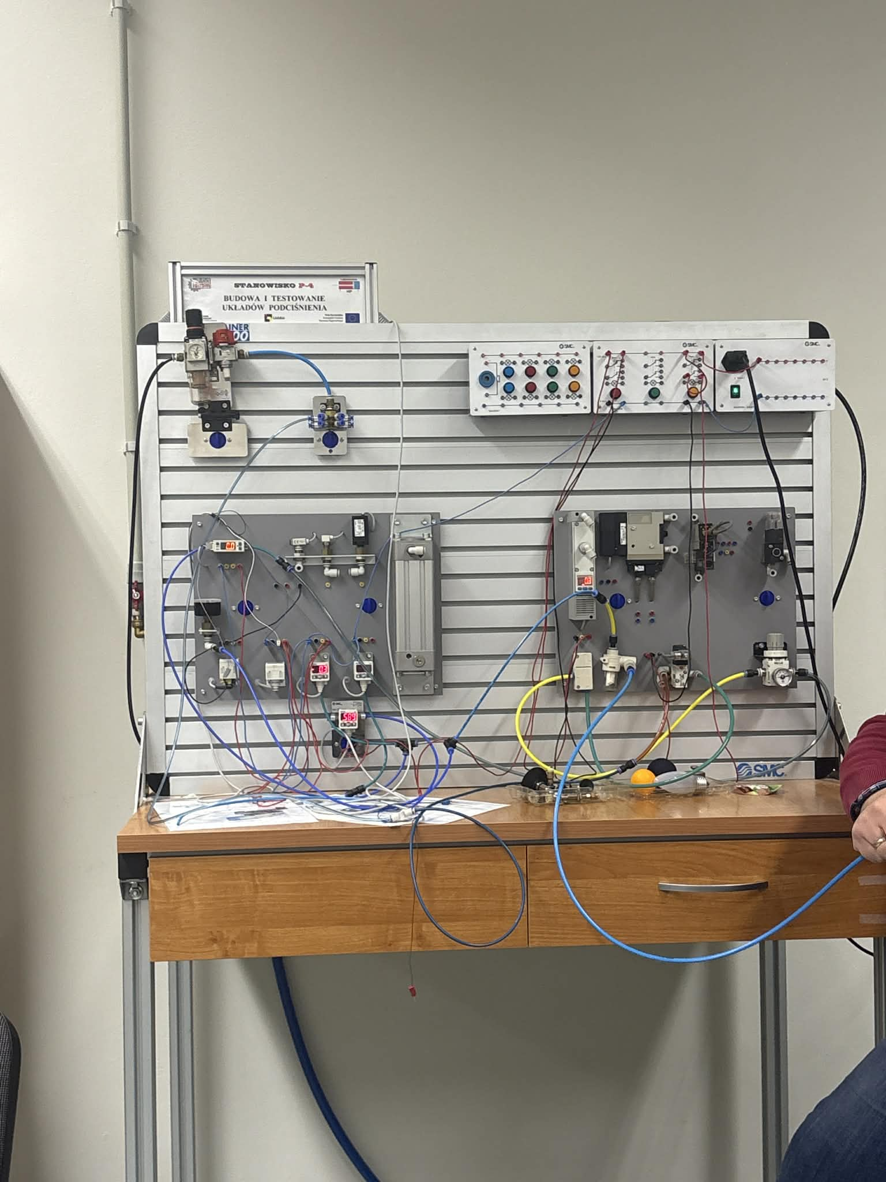
Figure 7

Measurements:
Table 3. Relationship between supply pressure [MPa] and negative pressure [kPa]
Supply pressure [MPa] | Negative pressure [kPa]
0 | 0
0,2 | 0,7
0,4 | 2,3
0,6 | 3,7
0,8 | 5,4
0,1 | 7,5
0,12 | 9,7
0,14 | 13,5
0,16 | 17,5
0,18 | 21,4
0,2 | 25,6
0,22 | 37
0,24 | 39
0,26 | 42,8
0,28 | 48,4
0,3 | 52,9
0,32 | 57,2
0,34 | 61,1
0,36 | 64,8
0,38 | 67,5
0,4 | 70,3
0,42 | 74,8
0,44 | 77,8
0,46 | 85
0,48 | 85,6
0,5 | 86
0,52 | 85,9
0,54 | 85,7

Observations:
When the supply pressure increases, negative pressure in vacuum also increases but only to certain value (maximum value, in our case it was 86 MPa), then the value of the negative pressure starts to decrease. This change in values is caused because at a certain point, the airflow through the ejector reaches its maximum speed, which is the speed of sound, and then increasing the supply pressure doesn’t improve the vacuum.
This is due to the system's physical and design limitations, such as the form of the nozzle and flow resistance, which restrict it from producing further suction. Beyond this limit, most of the additional energy gained from higher supply pressure is lost as heat or turbulence, resulting in decreased vacuum performance.

Plot:
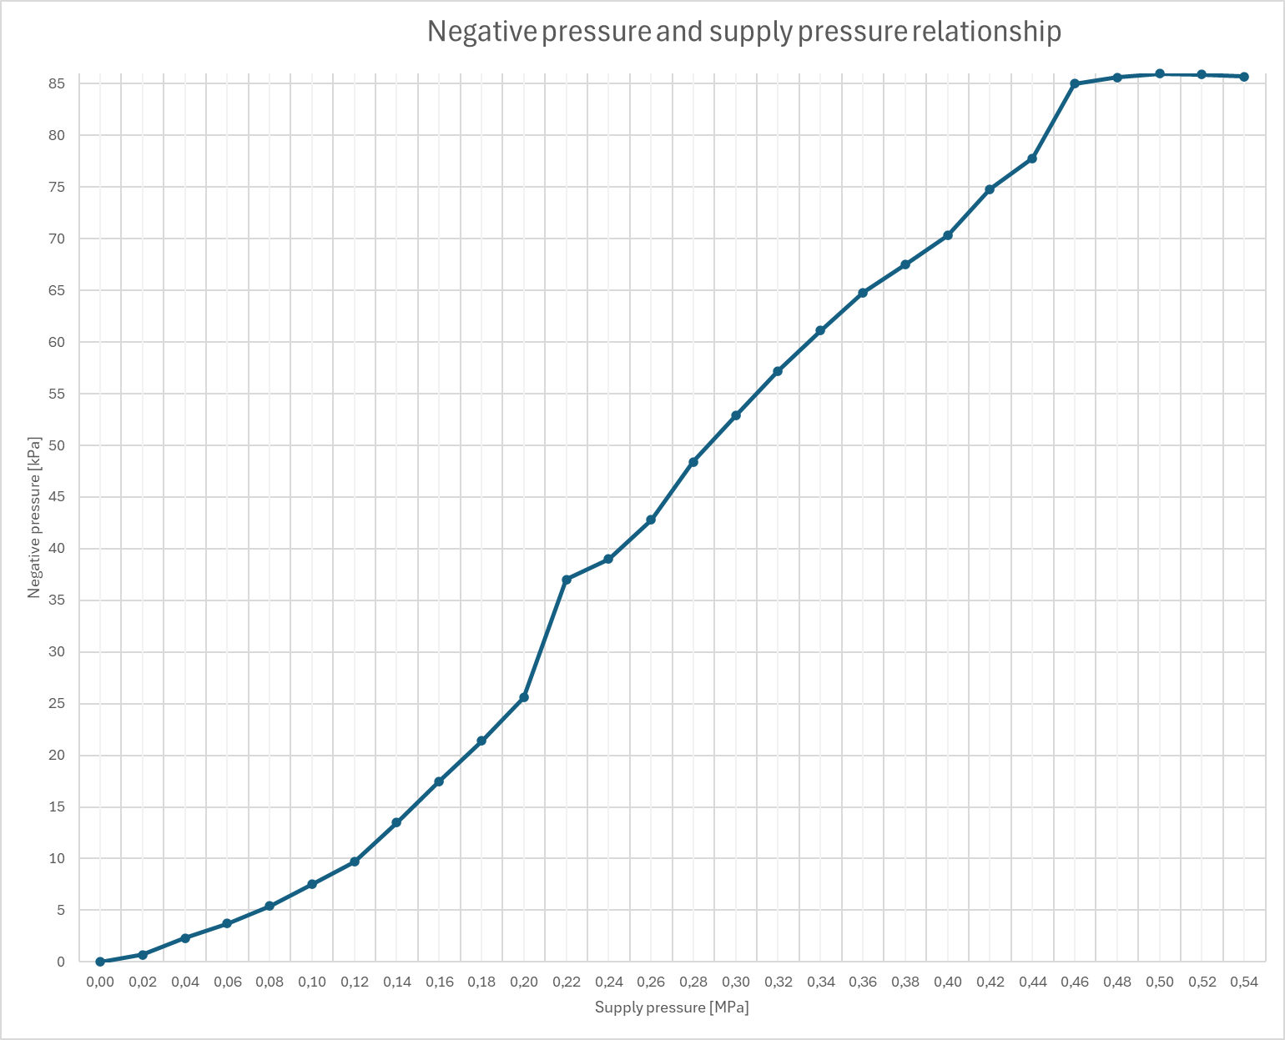
Figure 8. Graph presenting relationship between negative pressure and supply pressure

Conclusions:
To sum up, during our Vacuum Technology laboratory classes we gained both theoretical and practical knowledge about vacuum generation and measurement methods used during manufacturing processes. We’ve had possibility to learn where and how are they used, the different types and option to use them. The experiments helped us observe the relationship between pressure and volume of the workpiece, which was a great experience. By adjusting positions of the cylinders in different models we could observe how even small change in the pressure can affect the movement and speed of the working equipment. These practical exercises strengthened our understanding of theoretical concepts discussed in class. Overall, the laboratory provided valuable hands-on experience essential for modern manufacturing applications.

Sources:
https://ife.edu.p.lodz.pl/pluginfile.php/194862/mod_resource/content/1/Manuf_Inst_Lab_2022.pdf
https://www.youtube.com/watch?v=njTKjEpJpK0
https://arvacuuminfo.files.wordpress.com/2016/11/60-gk-3.jpg?w=1472
Microsoft Word - Manufacturing - Instructions for Laboratory v8 after revision. AGdocx.docx

